Ethics Council Meeting Minutes
Thursday, April 11, 2024

Call to Order
Louis Borowicz, Ethics Council Chair, called the meeting to order at 6:17 p.m. on Thursday, April 11, 2024

Roll Call
Members Present: Louis Borowicz, David Moser, and Howard Heffelfinger
Others Present: Tina Overturf, Senior Director of Programs and Services; Kristine Hodge, Superintendent; Amy Funk, Senior Director of Operations and Finance; and Jennifer Bianchi, Executive Assistant

Public Comments
None

Approval of March 14, 2024 Minutes
David Moser moved to approve the minutes from the March 14, 2024 Ethics Council meeting. Howard Heffelfinger seconded the motion. The motion carried.

Consent Agenda
The Ethics Council reviewed the following direct service contracts with no known conflicts: Advocating Choices Support Care, LLC.
David Moser moved to approve the consent agenda. Louis Borowicz seconded the motion. The motion carried.
Adjournment
Howard Heffelfinger moved to adjourn the meeting. David Moser seconded the motion. The meeting adjourned at 6:18 p.m.

Respectfully submitted,
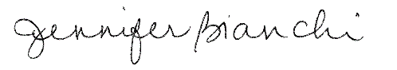
Jennifer Bianchi
Executive Assistant

