Ethics Council Meeting Minutes
Thursday, June 13, 2024

Call to Order
Louis Borowicz, Ethics Council Chair, called the meeting to order at 6:21 p.m. on Thursday, June 13, 2024

Roll Call
Members Present: Louis Borowicz, Howard Heffelfinger and David Moser
Others Present: Kristine Hodge, Superintendent; and Jennifer Bianchi, Executive Assistant

Public Comments
None

Approval of May 9, 2024 Minutes
David Moser moved to approve the minutes from the May 9, 2024 Ethics Council meeting. Howard Heffelfinger seconded the motion. The motion carried.

Staff Request
Howard Heffelfinger moved to approve Danielle Hudson’s request for secondary employment. David Moser seconded the motion. The motion carried.

Adjournment
David Moser moved to adjourn the meeting. Howard Heffelfinger seconded the motion. The meeting adjourned at 6:22 p.m.

Respectfully submitted,
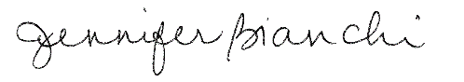
Jennifer Bianchi
Executive Assistant

