Ethics Council Meeting Minutes
Thursday September 12, 2024

Call to Order
Louis Borowicz, Ethics Council Chair, called the meeting to order at 6:16 p.m. on Thursday, September 12, 2024

Roll Call
Members Present: Louis Borowicz and Howard Heffelfinger
Others Present: Chase Waits, Director of Communications and Community Engagement; and Allison Walters, Director of Human Resources

Public Comments
None

Approval of June 13, 2024 Minutes
Howard Heffelfinger moved to approve the minutes from the June 13, 2024 Ethics Council meeting. Louis Borowicz seconded the motion. The motion carried.

Staff Requests
Howard Heffelfinger moved to approve Katie Etheridge’s request for secondary employment. Louis Borowicz seconded the motion. The motion carried.

Howard Heffelfinger moved to approve Melissa Ritchard’s request for secondary employment. Louis Borowicz seconded the motion. The motion carried.

Consent Agenda
The Ethics Council reviewed the following direct service contract with no known conflict: Align Health, LLC
Howard Heffelfinger moved to approve the consent agenda. Louis Borowicz seconded the motion. The motion carried.

Adjournment
Howard Heffelfinger moved to adjourn the meeting. Louis Borowicz seconded the motion. The meeting adjourned at 6:18 p.m.

Respectfully submitted,
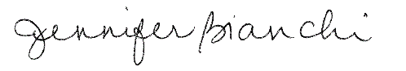
Jennifer Bianchi
Executive Assistant

