Ethics Council Meeting Minutes
Thursday November 14, 2024

Call to Order
Louis Borowicz, Ethics Council Chair, called the meeting to order at 6:16 p.m. on Thursday, November 14, 2024

Roll Call
Members Present: Louis Borowicz and Howard Heffelfinger
Members Absent: Erica Fouss
Others Present: Kristine Hodge, Superintendent; Amy Funk, Senior Director of Operations and Finance and Jennifer Bianchi, Executive Assistant

Public Comments
None

Approval of September 12, 2024 Minutes
Howard Heffelfinger moved to approve the minutes from the September 12, 2024 Ethics Council meeting. Louis Borowicz seconded the motion. The motion carried.

Staff Requests
Howard Heffelfinger moved to approve Lindsey Lenhart’s request for secondary employment. Louis Borowicz seconded the motion. The motion carried.

Consent Agenda
The Ethics Council reviewed the following contracts with no known conflict: Core Team contracts: ABC Therapies, Inc.; Keller Speech Therapy, LLC; Petras Pediatric Rehab, LLC; Professional Speech Services, Inc.; Sensory Solutions, LLC; Something to Say, LLC; and Professional Services contract: Best Payments, LLC.
Howard Heffelfinger moved to approve the consent agenda. Louis Borowicz seconded the motion. The motion carried.

Adjournment
Howard Heffelfinger moved to adjourn the meeting. Louis Borowicz seconded the motion. The meeting adjourned at 6:18 p.m.

Respectfully submitted,
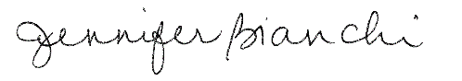
Jennifer Bianchi
Executive Assistant

